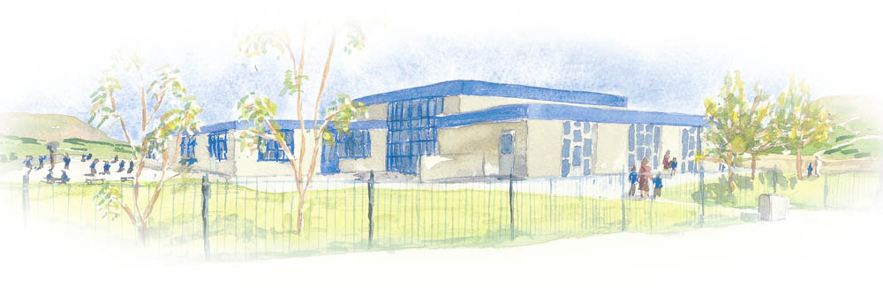

Broadway Primary School
SEND Information Report

How does the school know if children need extra help?
At our school we try to make sure that children with special educational needs and/or Disabilities (SEND) are identified and assessed as early as possible. This is achieved through a variety of ways such as:

-Whole school assessment to carefully monitor children’s progress and identify any areas of difficulty.
-Teachers may raise concerns about a child’s progress or social and emotional development.
-Parents may raise concerns about their child.
-A child may already have been identified with special educational needs and/or Disabilities in pre-school/nursery or a previous school.

Any concerns that school may have, are raised with parents and ways to support their child are discussed.

What should I do if I think my child may have special educational needs?
If you are concerned about your child, you can contact your child’s class teacher; Mrs Mary Pedder the Special Educational Needs and Disabilities Co-ordinator (SENDCO) or Mr Chris Bolton the Head teacher.

We operate an Open-Door policy with regards to any concerns a parent may have and will deal with them sensitively and promptly.

How will school support my child?
Typically, a child with Special Educational Needs and/or Disabilities will have specific outcomes and work planned for them by the class teacher related to the child’s needs. The SENDCO will oversee this and organise any additional help that is necessary. The support/interventions provided for SEND children are recorded on their termly Teaching and Learning Plans or their Personalised Provision Plans. The progress and support given to SEND children is monitored closely in order to help them meet their full potential.

How will the school staff support my child?
In our school there are 11 Teaching Assistants, 3 Higher Learning Teaching Assistants and a Learning Mentor that works with children in and outside the classroom to support their learning and emotional well-being. The expertise of outside agencies is also sought as and when necessary, so that we can meet the learning needs of all our children.

How will I know how my child is doing?
Parents are invited to meetings three times a year to discuss new outcomes and review their child’s progress. Children are also involved in this process so that school, parents and children work in partnership.

How is the decision made about the type and how much support my child will receive?
The nature and amount of support given to a child is based on the child’s needs and the progress made.
This is reviewed termly and discussed with parents during the meeting.

How will my child be included in activities outside the school classroom including school trips?
All children whether they have special educational needs/disabilities or not will be involved in the full life of the school. Our school aims to ensure that all children have full access to a broad, balanced curriculum and extra-curricular activities including trips. Risk assessments are undertaken when trips are planned and the appropriate support put in place as and when necessary.

What support will there be for my child’s overall well-being?
We have a Learning Mentor who specifically works with children focussing on their emotional well-being. For some children this may be a short-term intervention due to changes in family life and for others the support may need to be more long term. The amount of support provided is based on the needs of the individual child.

What specialist services and expertise are available at or accessed by the school?
We use a variety of specialist services that are provided through the authority or from private consultants. These include Specialist Teachers, Educational Psychologists and Speech and Language Therapists which help school to meet the individual needs of children. The SENDCO is qualified to teach children with dyslexia and diagnose Irlen’s Syndrome. One of the Higher Learning Teaching Assistants is also British Sign Language (BSL) Level 2 qualified, another one of our Higher Learning Teaching Assistants is a qualified Forest School leader, and all children have access to forest school during part of the year. Within school, we also have a behaviour support team that support pupils that may have communication and interaction difficulties or social, emotional and mental health difficulties.
What training have the staff supporting SEND had or what training are they having?
Staff have the opportunity to develop their own skills and knowledge via the on-line platform The National College and Acorn Psychology Training Hub. Whole school training was provided in 2023 to refresh and upskill staff knowledge on Autism. In January 2024 the Acorn Training Hub was used to refresh staff on an intervention called Precision Teaching. School is currently involved in training on “Teach Active” and Kagan Training which form part of quality first teaching for pupils and is integral to our GROW curriculum.

Regular advice from specialist teachers and Educational Psychologists also enable staff to develop their knowledge and understanding of how to meet the needs of SEND pupils. Some TA’s work closely with the Speech and Language Therapist and are supported with training to deliver specific programmes to individuals and groups.

How accessible is the school both indoors and outdoors?
Our school is on a single level and is fully wheelchair accessible with all doorways and entrances to the school being wide enough to accommodate a wheelchair. There are accessible parking spaces available by arrangement for the public and disabled persons and a disabled toilet for wheelchair users if the need should arise. There is also a high riser wall mounted changing bench in the disabled toilet which is used as and when necessary. The furniture in school is modern and of a suitable height appropriate to the age group of children being taught in that classroom.

How are parents involved in the school? How can I get involved?
There is an annual induction meeting for parents of new Reception children. The meeting gives parents the opportunity to meet the class teacher and find out more about the school. During the meeting a member of the PTFA also addresses the group and talks about the valuable work they do for the school and invites new parents to become members of the PTFA.

Who can I contact for further information?
If you need any further information, you can contact the Head Teacher or the SENDCO by email or ring the school/make an appointment.

How will the school prepare and support my child to transfer to a new setting or next stage of education and life?
Children in Year 5 have the opportunity to attend a “taster” day at the local High School. Each year pupils visit their forthcoming High School for taster sessions and the teachers from the local High Schools visit to help ease the transition from Year 6 to Year 7. We can also organise extra visits for SEND children and put in place a transition plan to help them prepare for their new High School

Mrs Mary Pedder
senco@broadway.lancs.sch.uk
01706 229832

