Curriculum Area | Autumn One | Autumn Two |  | Spring One | Spring Two | Summer One | Summer Two
 | Marvellous Me | Let’s Get Building |  | Down in the Jungle | The Pirates are Coming | Dangerous Dinosaurs | Oh, we do love to be by the seaside!
English  (Literacy/Communication and Language/Physical Development) | 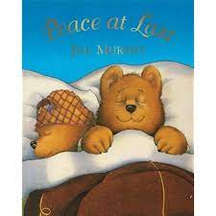  Peace at Last –  Jill Murphy | 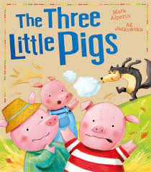  The Three Little Pigs – Mara Alperin |  | 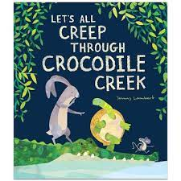  Let’s all Creep Through Crocodile Creek – Jonny Lambert | 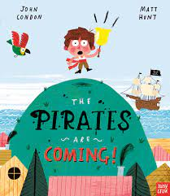  The Pirates are Coming – John Condon | 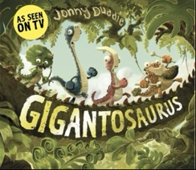  Giganotosaurus – Jonny Duddle | 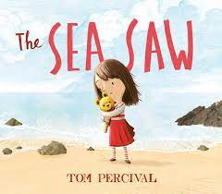  The Sea Saw – Tom Percival
Talk for Writing Story  (Literacy/Communication and Language/Physical Development) | Peace at Last | The Gingerbread Man |  | Let Me Come in | Little Jack | The Enourmous Turnip | The Sleepy Bumblebee
Styles of Writing  (Literacy/Communication and Language/Physical Development) | Story Map | Card |  | List | Letter | Book | Story
Nursery Rhymes  (Literacy/Communication and Language/Physical Development) | 1. This Little Piggy  2. Diddle Diddle Dumpling  3. Georgie Porgie  4. Pat a Cake  5. One, Two, Buckle My Shoe  6. Rain, rain, go away | 1. I’m a Little Teapot  2. Little Bo Peep  3. Little Miss Muffet  4. London Bridge  5. Hey Diddle Diddle  6. Hickory Dickory Dock  7. Ring O’Roses |  | 1. Wind the Bobbin Up  2. Rock a Bye Baby  3. Twinkle Twinkle Little Star  5. Heads, Shoulders, Knees and Toes  4. If You’re Happy and You Know It  5. It’s Raining, It’s Pouring  6. Old King Cole | 1. The Hokey Cokey  2. Hot Cross Buns 3. Humpty Dumpty  4. Horsie Horsie  5. She’ll Be Coming Round the Mountain  6. Sing A Song of Sixpence  7. Oranges and Lemons | 1. Mary, Mary, Quite Contrary  2. Little Tommy Tucker  3. Pop Goes the Weasel  4. Old Mother Hubbard  5. Wee Willy Winkie  6. Jack be Nimble  7. Jack and Jill | 1. See Saw, Margery Daw  2. Simple Simon  3. Frere Jaques  4. There Was an Old 5. Woman Who Lived in A Shoe  6. The Queen of Hearts  7. Sing A Song of Sixpence
Makaton Signs  (Literacy/Communication and Language/Physical Development) | Hello  Goodbye  Good Morning  Good Afternoon  Please  Thank you  Toilet  Weather | Classroom Signs  Christmas  Food Items  Alphabet |  | Classroom Signs  Food Items  Animals | Food Items  Sea Creatures  Days of the Week | Colours Classroom Signs  Food Items | Seaside Themed Signs  Food Items  Conversational Signs
Numeracy  Mathematics | Match, sort and compare  Match objects  Match pictures and objects  Identify a set  Sort objects to a type  Explore sorting techniques  Create sorting rules  Compare amounts  Talk about measure and patterns  Compare size  Compare mass  Compare capacity  Explore simple patterns  Copy and continue simple patterns  Create simple patterns  It’s me 1, 2, 3  Find 1, 2 and 3  Subitise 1, 2 and 3  Represent 1, 2 and 3 | It’s me 1, 2, 3  1 more  1 less  Composition of 1, 2 and 3  Circles and Triangles  Identify and name circles and triangles  Compare circles and triangles  Shapes in the environment  Describe position  1, 2, 3, 4, 5  Find 4 and 5  Subitise 4 and 5  Represent 4 and 5  1 more  1 less  Composition of 4 and 5  Composition of 1-5  Shapes with 4 Sides  Identify and name shapes with 4 sides  Combine shapes with 4 sides  Shapes in the environment  My day and night  Alive in 5  Introduce zero  Find 0 to 5  Subitise 0 to 5  Represent 0 – 5  1 more  1 less  Composition  Conceptual subitising to 5 |  | Mass and Capacity  Compare mass  Find a balance  Explore capacity  Compare capacity  Growing 6, 7, 8  Find 6, 7 and 8  Represent 6, 7 and 8  1 more  1 less  Composition of 6, 7 and 8  Make pairs – odd and even  Double to 8 (find a double)  Double to 8 (make a double)  Combine 2 groups  Conceptual subitising  Length, Height and Time  Explore length  Compare length  Explore height  Compare height  Talk about time  Order and sequence time | Building 9 and 10  Find 9 and 10  Compare numbers to 10  Represent 9 and 10  Conceptual subitising to 10  1 more  1 less  Composition to 10  Bonds to 10 (2parts)  Make arrangements of 10  Bonds to 10 (3parts)  Doubles to 10 (find a double)  Doubles to 10 (make a double)  Explore even and odd  Explore 3-D Shapes  Recognise and name 3-D shapes  Find 2-D shapes within 3-D shapes  Use 3-D shapes for tasks  3-D shapes in the environment  Identify more complex patterns  Copy and continue patterns  Patterns in the environment | To 20 and Beyond  Build numbers beyond 10 (10-13)  Continue patterns beyond 10 (10-13)  Build numbers beyond 10 (14-20)  Continue patterns beyond 10 (14-20)  Verbal counting beyond 20  Verbal counting patterns  How many now?  Add more  How many did I add?  Take away  How many did I take away?  Manipulate, Compose and Decompose  Select shapes for a purpose  Rotate shapes  Explain shape arrangements  Compose shapes  Decompose shapes  Copy 2-D shape pictures  Find 2-D shapes within 3-D shapes  Sharing and Grouping  Explore sharing  Sharing  Explore grouping  Grouping | Sharing and Grouping  Even and odd sharing  Play with and build doubles  Visualise, Build and Map  Identify units of repeating patterns  Create own pattern rules  Explore own pattern rules  Replicate and build scenes and constructions  Visualise from different positions  Describe positions  Give instructions to build  Explore mapping  Represent maps with models  Create own maps from familiar places  Create own maps and plans from story situations  Make Connections  Deepen understanding  Patterns and relationships
Understanding the World
Science  (Understanding the World) | Our Bodies  Night and Day | Water Freezing  Shadows  Materials |  | Hot and cold Climates  Animals and their Habitats | Sea Creatures and Animals  Floating and Sinking | Plants and Growing  Healthy Foods  Life Cycles | Magnets  Light and Dark
Welly Walk Wednesdays  Science and Geography  (Understanding the World) | Autumn  Leaves  Owls  Spiders  Nocturnal Animals  Autumn Walk – Seasonal Changes | Winter  Stars  Hibernation  Robins  Sticks  Worms  Winter Walk – Seasonal Changes |  | Winter  Ice  Mountains  Winter Trees  Snowflakes  Winter Walk – Seasonal Changes | Spring  Rain  Nests  Moon  Spring Flowers  Spring Walk – Seasonal Changes | Spring  Beans  Seeds  Tadpoles  Rainbows  Spring Walk – Seasonal Changes | Summer  Caterpillars and Butterflies  Bees  Clouds  Summer Walk – Seasonal Changes
Geography  (Understanding the World) | School Environment  Where we live  Floor Plans | Our Homes  Homes in other countries  Local Area  Local Buildings |  | Simple maps based on journeys  Hot and Cold Countries | Names of different countries  Simple Maps  Pollution | Volcanoes  Plants in the environment around them | Weather  Costal Features
History  (Understanding the World) | My Family and Me  The Stove – Home Corner  Sweeping Brush – Home Corner  Cuckoo Clock – Home Corner  Fruit and Vegetables  Carrots  Potatoes  Broccoli  Apples  Bananas  lemons | Haslingden through the years  Christmas Decorations – Home Corner  Clothes Horse – Home corner  Easy Chair – Home Corner  Fruit and Vegetables  Pumpkins  Sprouts  Cauliflower  Plums  Cranberries  Oranges |  | Toys from the Past  Bathing a baby – Home Corner  Baby clothes – Home corner  Telephones – Home Corner  Fruit and Vegetables  Sweet Potato  Green beans  Peppers  Grapes  Strawberries  Grapefruit | Games from the Past  Washing Clothes– Home Corner  Ironing – Home corner  Typewriter – Home Corner  Fruit and Vegetables  Onions  Beetroot  Celery  Figs  Kiwi  Pomegranate | A very long time ago when Dinosaurs lived  Allotment – Home Corner  Tea Pot – Home corner  Radio – Home Corner  Fruit and Vegetables  Lettuce  Peas  Asparagus  Peach  Lime  Passion Fruit | Going to the Seaside  Swimming Costume – Home Corner  Punch and Judy – Home corner  Camera – Home Corner  Fruit and Vegetables  Spinach  Cucumber  Sweetcorn  Papaya  Tomatoes  Cherries
Religious Education  (Understanding the World) | Key Question – Why are some things special?  Focus Question – Special Times  How and why do we celebrate? |  |  | Key Question – Why are some things special?  Focus Question – Special Stories  Why are some stories special?  What special messages can we learn from stories? |  | Key Question – Why are some things special?  Focus Question – Special Places  What is special about our world?
Expressive Arts and Design
Art  (Expressive Arts and Design) | Lines Artwork  Bridget Riley    Drawing  Painting  Sculpture  Collage | Starry Night Artwork  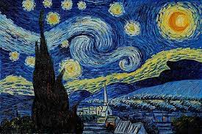  Vincent Van Gough  Drawing  Painting  Sculpture  Collage |  | Hot and Cold Colours  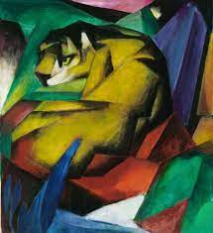  Franz Marc  Drawing  Painting  Sculpture  Collage | Printing from Nature  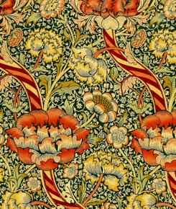  William Morris  Drawing  Painting  Sculpture  Collage | Sunflowers Artwork  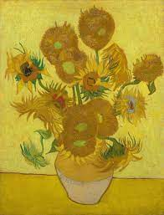  Vincent Van Gough  Drawing  Painting  Sculpture  Collage | Shapes in Art  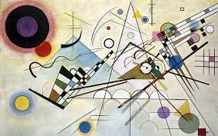  Kandinsky  Drawing  Painting  Sculpture  Collage
Forest School

Art Inspired by our Living World
 | Andy Goldsworthy  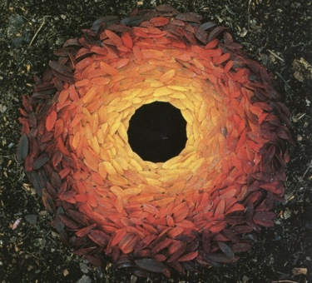 |  | Miranda Lloyd  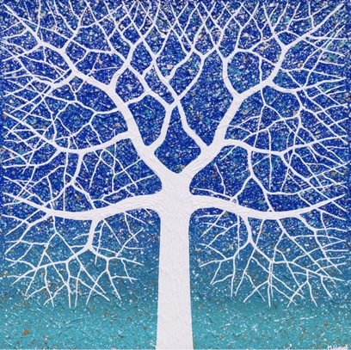 |  |  | 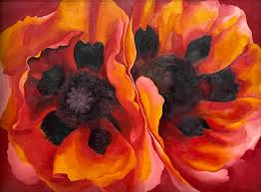  Georgia O’Keeffe
Design and Technology  (Expressive Arts and Design) | Creating with Materials  Paper Manipulation  Joining Materials  Fold  Sticking  Glue stick  PVA glue  Scissor Skills  Using materials to make a room in their home. | Creating with Materials  Paper Manipulation  Joining Materials  Bend  Tape  Scissor Skills  Masking tape  Sellotape  Using materials to make a home for the Three Little Pigs. |  | Creating with Materials  Paper Manipulation  Joining Materials  Scrunch  Weave  Scissor Skills  Split pins  Using recycled materials to make an animal. | Creating with Materials  Paper Manipulation  Joining Materials  Rip  Tie  Scissor Skills  Hole punch  Using recycled materials to make a pirate ship. | Creating with Materials  Paper Manipulation  Joining Materials  Curl  Link  Scissor Skills  Stapler  Using recycled materials to make a dinosaur. | Creating with Materials  Paper Manipulation  Joining Materials  Brace  Flange  Scissor Skills  Glue gun  Using recycled materials to make a picture of the beach.
Music  (Expressive Arts and Design) | Music and Movement  Action songs  Finding the beat  Exploring tempo  Exploring tempo and pitch through dance  Performance  Nursery Rhymes and Action Songs | Celebration Music  Diwali music  Hanukkah music  Kwanzaa music  Traditional Christmas music  Christmas action songs  Nursery Rhymes and Action Songs |  | Exploring Sound  Vocal sounds  Body sounds  Instrumental sounds  Environmental sounds  Nature sounds  Nursery Rhymes and Action Songs | Musical Stories  Moving to music  Using instruments to represent characters  Storytelling with actions  Sing instruments to represent actions  Musical story composition  Performance  Nursery Rhymes and Action Songs | Choir Time  The children will learn a selection of songs together which they will sing as a choir and perform to parents  Nursery Rhymes and Action Songs | Big Band  What makes an instrument?  Introduction to orchestra  Follow the beat  Tunes and untuned instruments  Performance  Nursery Rhymes and Action Songs
Other Areas of Learning
Computing | In Reception, children have a computing session each week where they learn basic keyboard and mouse skills.  Children have opportunities to se ICT in class during lessons and through continuous provision.
Online Safety | During Computing session, children learn about how to keep safe online. Online safety is also taught through PSHE in Reception.
Physical Education  (Physical Development) | Develop balance  To negotiate space  Fundamental Movement Skills  To climb with confidence  To develop gymnastic rolls | Develop balance  To negotiate space  Fundamental Movement Skills  To climb with confidence  To develop gymnastic rolls |  | Develop balance  To negotiate space  To develop different ways of travelling  Fundamental Movement Skills  To climb with confidence  To develop gymnastic rolls | Develop balance  To negotiate space  Fundamental Movement Skills  To climb with confidence  To develop gymnastic rolls | Develop balance  To negotiate space  Fundamental Movement Skills  To climb with confidence  To develop gymnastic rolls | Develop balance  To negotiate space  Fundamental Movement Skills  To climb with confidence  To develop gymnastic rolls
 | 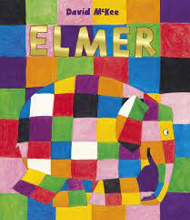 | 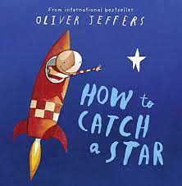  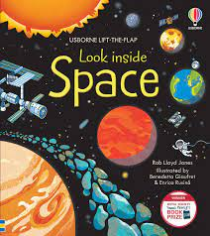 |  | 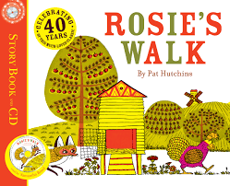  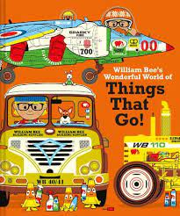 | 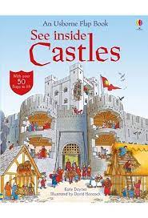  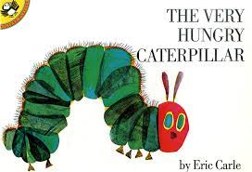 | 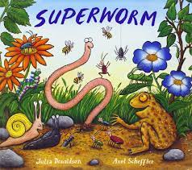  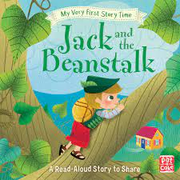 | 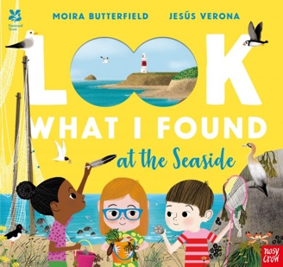  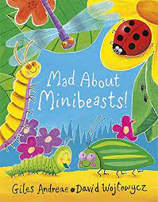
PSHE  (Personal, Social and Emotional Development) | Me and My Relationships  All about me  What makes me special  Me and my special people  Who can help me?  My feelings | Valuing Difference  I’m special, you’re special  Same and different  Same and different families  Same and different homes  I am caring  I am a friend |  | Keeping Safe  What’s safe to go onto my body  Keeping myself safe – What’s safe to go into my body (medicines)  Safe indoors and outdoors  Listening to my feelings  Keeping safe online  People who keep me safe | Rights and Respect  Looking after my special people  Looking after my friends  Being helpful at home and caring for our classroom  Caring for our world  Looking after money: recognising, spending, using  Looking after money: saving money and keeping it safe | Being my Best  Bouncing back when things go wrong  Yeas, I can!  Healthy eating  My healthy mind  Move your body  A good night’s sleep | Growing and Changing  Seasons  Life stages – plants, animals, humans  Life stages: Human life stage – who will I be?  Where do babies come from?  Getting bigger  Me and my body – girls and boys
British Values  (Personal, Social and Emotional Development) | Respect  We value respect by showing good behaviour and polite manners  Responsibility  We value our responsibility within our community | Kindness  We value kindness as it helps us build friendships  Diversity  We value diversity by respecting everyone’s differences |  | Loyalty  We value loyalty because it means we can trust and depend on each other  Team Work  We value team work as together we learn | Honesty  We value honesty by always telling the truth and taking responsibility for our actions  Forgiveness  We value forgiveness as it shows strength of character | Effort  We value effort as it shows our determination to succeed  Determination  We value determination so we can tackle difficulties in school and in life | Courage  We value courage as taking risks helps us become confident people  Curiosity  We value curiosity as this creates an atmosphere where all questions are valued
Curriculum Enhancements | Visit from the Life Education Van  Seasonal Walk in Haslingden | Visit from a Police Officer  Seasonal Walk in Haslingden |  | African Drumming Workshop  A parent and baby  A visit from a midwife  Trip to the Travel Agents | Visit to the Post Office  Seasonal Walk in Haslingden | Duckling Hatching  Visit from Firefighter | Seasonal Walk in Haslingden  Trip to the Seaside  Visit from RNLI
Celebrations | Harvest Festival | Halloween  Bonfire Night  Remembrance Day  Diwali  Advent  Christmas |  | Chinese New Year  Pancake Day  Valentine’s Day | Ramadan  St Patrick’s Day  Mother’s Day  Holi  Easter  Eid | Father’s Day

